**Center Name: ACE-HCMC-2-FPT.**

**Address: 590 Cach Mang Thang 8, District 3, Ho Chi Minh City, Viet Nam.**

**Vehicle Insurance Portal**

**Design Document**

| **Supervisor:** | Mr. Nguyen Kim Thuan | |
| --- | --- | --- |
| **Semester:** | 3 | |
| **Batch No:** | T1.2109.E0 | |
| **Group No:** | 4 | |
| **Order:** | **Full name** | **Roll No.** |
| 1. | Nguyen Ngoc Kim Ngan | Student 1317115 |
| 2. | Nguyen Toan | Student 1328430 |
| 3. | Truong Duong Truc Duy | Student 1333971 |
| 4. | Nguyen Phuc Duy | Student 1333974 |

**This is to certify that**

**Ms.** Nguyen Ngoc Kim Ngan

**Mr.** Nguyen Toan

**Ms.** Truong Duong Truc Duy

**Mr.** Nguyen Phuc Duy

**have successfully designed & developed:**

eProject: **Vehicle Insurance Portal**

**Submitted by:**

Mr. Nguyen Kim Thuan

**Date of issue:** 02/12/2022

**Authorized Signature:**

**Ms.** Nguyen Ngoc Kim Ngan

**TABLE OF CONTENTS**

**REVIEW 1** **6**

ACKNOWLEDGEMENT 7

I. Introduction 8

II. Problem Definition 9

III. Requirement Specification 10

1. Functional Requirement Specifications 10

2. Non-functional Requirement Specifications 13

3. System Requirement Specifications 13

**Task Sheet Review 1** **16**

**REVIEW 2** **17**

I. Architecture & Design of the Project 18

1 Presentation Tier 18

2 Business Logic Tier 18

3 Data Access Tier 18

II. Algorithms – Data Flowchart 19

1. Symbols generates 19

2. Login (all users) 19

3. Logout (all users) 19

4. Get an Estimate 20

5. Purchase Policy Online 21

6. Initiate a Claim 22

III. Use Case Diagram 23

1. Customer: 23

2. Employee: 24

IV. Entity - Relationship Diagram 25

**Task Sheet Review 2** **30**

**REVIEW 3** **31**

V. Site Map 32

1. Employee Site Map 32

2. Customer Site Map 33

VI. Database Design 34

1. Database Design Diagram 34

- Customer: 35

- Estimate: 36

- Certificate: 36

- Customer Bill: 36

- Claim: 37

VII. GUI Design 38

1. Employee 38

1.1. Login 38

1.2. Index page 39

1.3. Certificates page 40

1.4. Certificate Details - Maintain policy 42

1.5. Claims by this certificate 44

1.6. Claims 45

1.7. Maintain claims 46

1.8. Customer Bill 47

1.9. Maintain customer bill 48

1.10. Company Expense 49

1.11. Company Expense Details 50

1.12. Vehicle wise report page 51

1.13. Policies lapsed report 52

2. Customer 53

2.1. Header 53

2.2. Footer 53

2.3. Home 55

2.4. Personal Information 56

2.5. Change Password 57

2.6. Login 58

2.7. Register 59

2.8. About Us 60

2.9. Sitemap 60

2.10. Testimonials 62

2.11. Contact Us 63

2.12. List of Insurance Policies 63

2.13. My Claims 65

2.14. Form Claim 66

2.15. Estimate 67

2.16. Contract 69

2.17. Certificates 71

2.18. Certificate Details 72

2.19. Bill 72

2.20. Payment 73

**Task Sheet Review 3** **74**

# REVIEW 1

## ACKNOWLEDGEMENT

First and foremost, we would like to express the deepest appreciation to our admirable instructor – Mr. Nguyen Kim Thuan. During the time of the project, he continually and convincingly conveyed a spirit of adventure in regard to research and scholarship, and an excitement in regard to teaching. Without his guidance and persistent help this dissertation would not have been possible. Therefore, once again, we truly value your dedication and guidance, Mr. Thuan.

Next, it would have been impossible to carry out and complete this project without the collaboration among our team members. Although we have gone through many obstacles during the project implementation, eventually we gained what we aimed at by our hard work, our strong commitment and of course, our brotherhood.

Finally, thanks to Aptech’s eProject team, we had a golden opportunity to apply what we have learnt into reality and gain hands-on experience which is essential for our future career.

## I. Introduction

After being affected by the Covid-19 epidemic, many industries had to switch to online business activities.The Vehicle Insurance industry is also starting to digitize its business. On the internet, you can buy a product like Vehicle Insurance at any time and from anywhere. You can buy a Vehicle Insurance policy from the comforts of your home at midnight and you will still have a seamless experience. Buying Vehicle Insurance online provides convenience. This is not possible while buying Vehicle Insurance manually i.e from the insurance company or an agent.

In addition, Current manual system that is employed is extremely laborious and quite inadequate; it only makes the process more difficult and hard. Main purpose of this software should be to reduce the manpower, paperwork and provide security from unauthorized access. It should also help in producing difficult kinds of reports required for different managerial aspects.

## II. Problem Definition

The objective of the system is to provide the facilities to all the people concerned with Vehicle Insurance. From the management point of view works can be done fast and more accurately as compared to existing manual systems. From the customer’s point of view he can get immediate services without any kind of wasting of time whereas from the user’s point of view all kinds of transitions can be done in a very easy and efficient manner. The system also provides many kinds of report generation facilities.

This project aims to develop a complete fully functional independent system with the intention of improving the productivity of the operations of the company through speedy and accurate processing and efficient storage and retrieval of data. The basic aim behind this project is to provide a complete solution that manages the records of vehicle insurance companies.

**ADMIN**: ADMIN will login and have a master management access like ADMIN can update information of users, can update products,…

**Advantages**:

Making a purchase online has become very simple and buying Vehicle Insurance online is no more a big deal. Take a look at the following advantages if you are skeptical about buying your car insurance policy online. Benefits of buying Vehicle Insurance online: Data security, reduced paperwork, reduced manpower, increased operation efficiency, increased accuracy and reliability, improved moral, reduced operating time

**Disadvantages**: Users must register an account to buy the product.

## III. Requirement Specification

* Data Security
* Reduced Paperwork
* Reduced Manpower
* Increase Operational Efficiency
* Increase Accuracy And Reliability
* Improve Moral
* Reduce Operational Time

### Functional Requirement Specifications

|  | **Customer** | **Admin** |
| --- | --- | --- |
| **1.1.** **Login** | R1: Login with unique username, password  R2: Username, password incorrect then display error message  R3: Login successfully will direct to the Customer Page, there will be a bunch of functions that Customer can use.  R4: If login failed, still on login page | R1: Login with unique username, password.  R2: Username, password incorrect then display error message  R3: Login successfully will direct to the Admin Page, there will be a bunch of functions that Admin can use.  R4: If login failed, still on login page |
| **1.2.** **Types of insurance** | R1: Can estimate insurance packages by filling in the estimate form.  R2: Chooses available insurances  - Complete Care  - Comprehensive  - Third-Party Fire and Theft  - Third Party Property Damage | R1: Can view all Types of insurance.  R2: Can create new Types of insurance.  R3: Can edit each of Types of insurance.  R4: Can view Types of insurance of customers. |
| **1.3. Customer Purchase policy** | R1: Can request payment. If a customer wants to buy a vehicle insurance package the price has been estimated.  R2: Can make purchase policies by filling all information.  R3. Can send a Customer Purchase policy.  R4: Can choose only one type of insurance per purchase.  R5: Can view the price for the selected vehicle insurance package. | R1: Can view all policies.  R2: Can view details of each customer purchase policy. |
| **1.4 Claim(create and manage)** | R1: Can view list of claims and claim details.  R2: Can view insurance process  R3: Can make new claims when an accident occurs.  R4: Fill all information in form  R5. Send Claim. | R1: Can view all customer claims.  R2: Update status claim. |
| **1.6. Purchase policy process** | R1: Can view certificates.  R2: Confirm payment information.  R3: Can pay in cash. | R1: Can active customer policy by updating status.  R2: Can confirm the customer has paid in cash. |
| **1.7 Process Claims** | R1: Can Request for Claims to insurance company by filling in claims request.  R2: Waiting for Approve/Decline.  R3: if Approved: Claims payment.  if Declined: Customers have to refill the missing information. | R1: Can check customers' claims information.  R2: Can Approve/Decline customer’s claims.  R3: if Approved: give customers claims payment.  if Declined: ask the customer to refill the claims request information correctly. |
| **1.8 Change Password** | R1: Visit Change Password page.  R2: Change Password by filling in account information.  R3: Password changed. | R1: Visit Change Password page.  R2: Change Password by filling in account information.  R3: Password changed. |
| **1.9 Register** | R1: Visit Register Page.  R2: Filling in customer account information.  R3: Customer Account created. | R1: Visit Register Admin page.  R2: Filling in admin account information.  R3: Admin Account created. |
| **1.10 About us** | R1: Visit About Us Page.  R2: Can view insurance companies information. | R1: Visit About Us Page.  R2: Can edit insurance companies information. |
| **1.11 Testimonials** | R1: Visit Testimonials Page.  R2: Can write a testimonial and view other customers testimonials. | R1: Visit Testimonials Page.  R2: Can view customers testimonials. |
| **1.12 Sitemap** | R1: Visit Sitemap Page at footer.  R2: Can view the page sitemap. | none |
| **1.13 Contact us** | R1: Visit Contact Page.  R2: Can view contact information. | R1: Visit Contact Page.  R2: Can edit contact information. |

### 2. Non-functional Requirement Specifications

REQ-1. Good using Interface and Experience.

REQ-2. Clean code.

REQ-3. Try hard to improve the performance.

REQ-4. Try this website to run on all browsers.

REQ-5. Try to limit bugs on this website.

### 3. System Requirement Specifications

**3.1 Server Requirement:**

* Hardware:
* Component CPU:
  + Processor type:
  + Pentium IV-compatible processor or faster
  + Processor speed: Recommended: 2.0 GHz or faster
* OS:
  + Microsoft Windows XP or higher with IIS
* Memory (RAM):
  + Minimum: 512MB
  + Recommended: 2GB or more
* Hard Drive:
  + Minimum: 200 MB
  + Recommended: 50 GB or more
  + Maximum: Operating system maximum
* Software:
* ASP.NET Core Version .NET Core 6.0
* RDBMS SQL Server

**3.2 Client requirements:**

* Hardware:
* Component CPU:
  + Processor type:
  + Pentium IV-compatible processor or faster
  + Processor speed: Recommended: 2.0 GHz or faster
* OS:
  + Microsoft Windows XP or MacOS …
* Memory (RAM):
  + Minimum: 512MB
  + Recommended: 2GB or more
* Hard Drive:
  + Minimum: 512MB
  + Recommended: 1 GB or more
* Software:
* Web Browser: Microsoft Edge, Mozilla Firefox, Chrome

**3.3 Development Software:**

* Microsoft SQL server Management Studio
* Microsoft Visual Studio 2022.

**3.4 Technology:**

* ASP.Net Core 6.0
* Entity Framework Core 6.0.7

# Task Sheet Review 1

| **Project Ref. No.:**  **eP/Vehicle-Insurance- Management/04** | | **Project Title:** | **Activity Plan**  **Prepared**  **By:** | **Date of Preparation of Activity Plan:** | | | |
| --- | --- | --- | --- | --- | --- | --- | --- |
| **Sr. No.** | **Task** | **Actual Start**  **Date** | **Actual**  **Days** | **Team**  **Mate**  **Names** | **Status** |
| 1 | Introduction | Vehicle Insurance Portal | Nguyen  Ngoc Kim Ngan | 02Dec 2022 | 1 | All members | Completed |
| 2 | Problem Definition | 02Dec 2022 | 1 | All members | Completed |
| 3 | Requirement Specification | 02Dec 2022 | 1 | All members | Completed |
| 4 | Task sheet review | 02Dec 2022 | 1 | All members | Completed |
| **Date: 02/10/2022** | | | | | | | |
| **Signature of Instructor**    **Mr. Nguyen Kim Thuan** | | | | **Signature of Team Leader**    **Nguyen Ngoc Kim Ngan** | | | |

# 

# REVIEW 2

## I. Architecture & Design of the Project

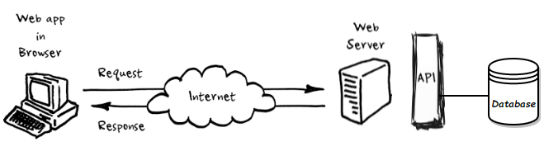

### Presentation Tier

* + - 1. This is the tier in which the users interact with applications. Presentation Tier contains Model, View, Controller used to receive a request and response to User.
      2. Technology: ASP.NET CORE MVC5, Razor, HTML, CSS, JavaScript, Ajax, JQUERY

### Business Logic Tier

* + - 1. Is mainly working as the bridge between Data Tier and Presentation Tier. All the Data passes through the Business Tier before passing to the Presentation Tier.
      2. Technology: OOP, ASP.NET CORE API

### Data Access Tier

* + - 1. This is basically the server which stores all the application’s data. Data tier contents Database Tables, Database Views and other means of storing Application’s data.
      2. Technology: SQL Server

## II. Algorithms – Data Flowchart

### Symbols generates

### 

### Login (all users)

### Logout (all users)

### Get an Estimate

## 

### Purchase Policy Online

* 1. **Submit Certificate form**

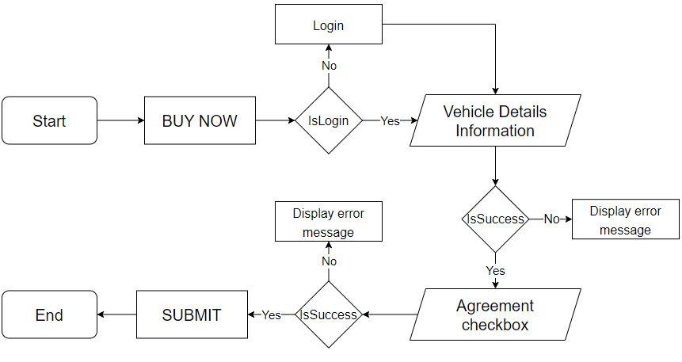

* 1. **Confirm Payment**

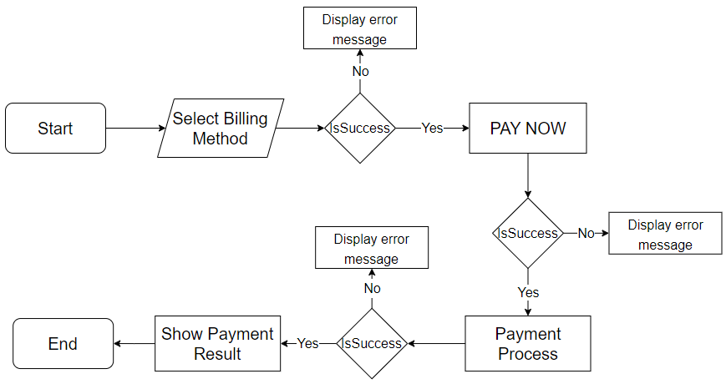

### Initiate a Claim

## 

## 

## 

## 

## 

## 

## 

## III. Use Case Diagram

## Customer:

## 

### **Employee:**

## 

## IV. Entity - Relationship Diagram

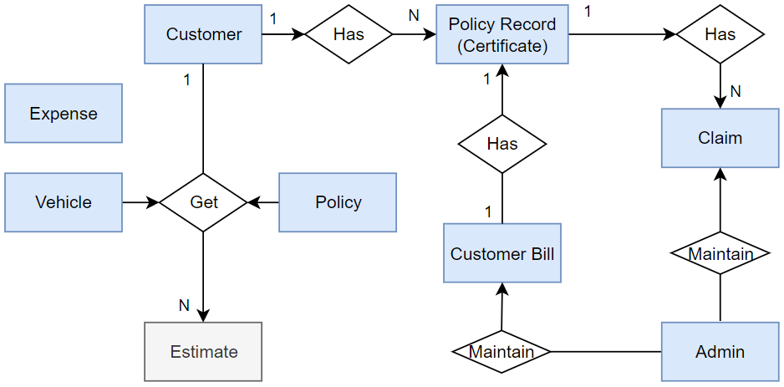

1. **Customer Entity:**

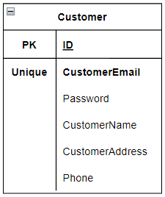

1. **Admin Entity:**

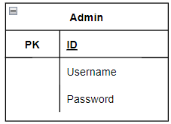

1. **Vehicle Entity**

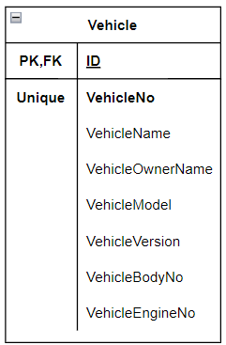

1. **Policy Entity:  
   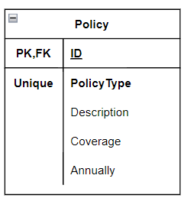**
2. **Estimate Entity:  
   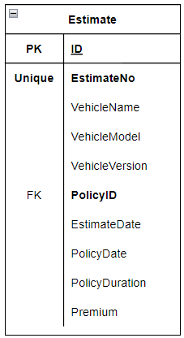**
3. **Certificate (Policy Record) Entity:  
   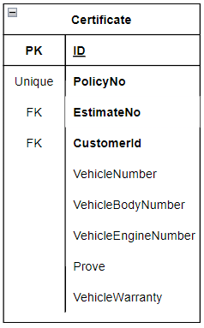**
4. **Customer Bill Entity:  
   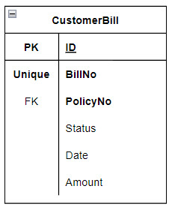**
5. **Claim Entity:  
     
   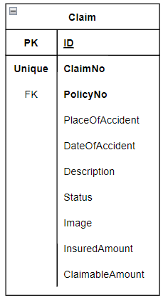**
6. **Expense Entity:  
   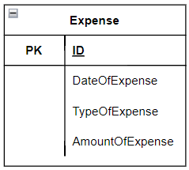**

# Task Sheet Review 2

| **Project Ref. No.:**  **eP/Vehicle-Insurance- Management/04** | | **Project Title:** | **Activity Plan**  **Prepared**  **By:** | **Date of Preparation of Activity Plan:** | | | |
| --- | --- | --- | --- | --- | --- | --- | --- |
| **Sr. No.** | **Task** | **Actual Start**  **Date** | **Actual**  **Days** | **Team**  **Mate**  **Names** | **Status** |
| 1 | Architecture & Design of Project | Vehicle Insurance Portal | Nguyen Ngoc Kim Ngan | 06Dec 2022 | 3 | All members | Completed |
| 2 | Algorithms - Data Flowchart | 06Dec 2022 | 3 | All members | Completed |
| 3 | Use Case Diagram | 06Dec 2022 | 3 | All members | Completed |
| 4 | Entity-  Relationship Diagram | 06Dec 2022 | 3 | All members | Completed |
| 5 | Task sheet review | 06Dec 2022 | 3 | All members | Completed |
| **Date: 06/10/2022** | | | | | | | |
| **Signature of Instructor**    **Mr. Nguyen Kim Thuan** | | | | **Signature of Team Leader**    **Nguyen Ngoc Kim Ngan** | | | |

# 

# 

# REVIEW 3

## V. Site Map

### Employee Site Map

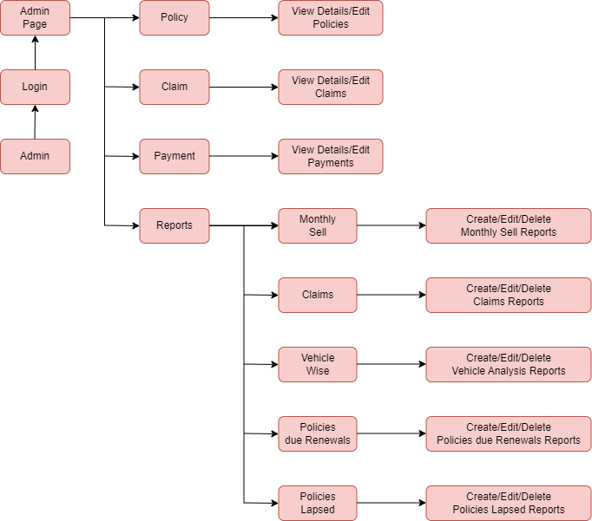

### Customer Site Map

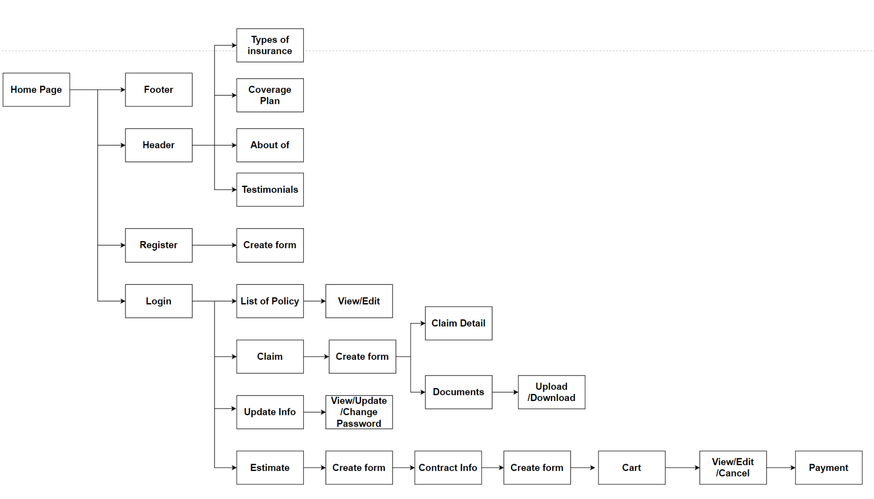

## 

## VI. Database Design

### Database Design Diagram

## 

### Customer:

* Vehicle:  
  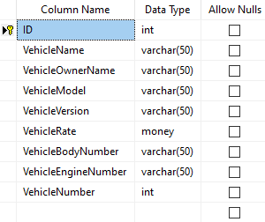
* Policy:  
  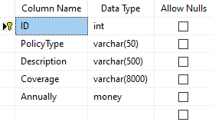

### Estimate:

### Certificate:

### Customer Bill:

### Claim:

* Expense:  
    
  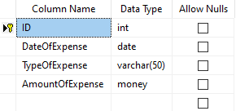
* Admin  
  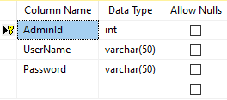

## 

## 

## 

## VII. GUI Design

### Employee

#### Login

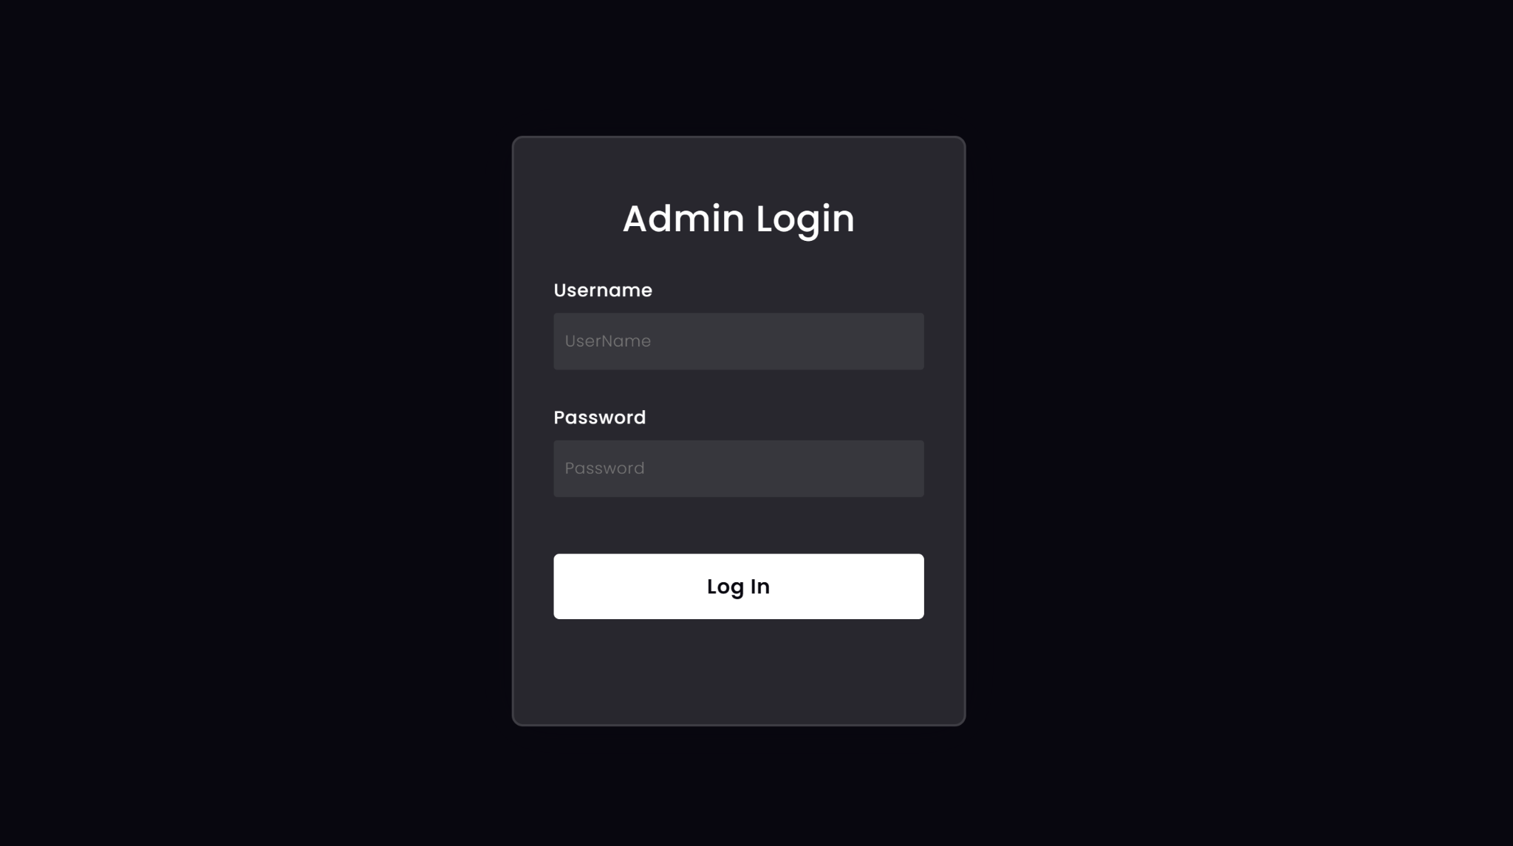

| **No.** | **Name** | **Validate** | **Type** | **Event** | **Description** |
| --- | --- | --- | --- | --- | --- |
| 1 | Username | Required | Textbox | On Type | Input Admin user |
| 2 | Password | Required | Textbox | On Type | Input Admin Account |

#### Index page

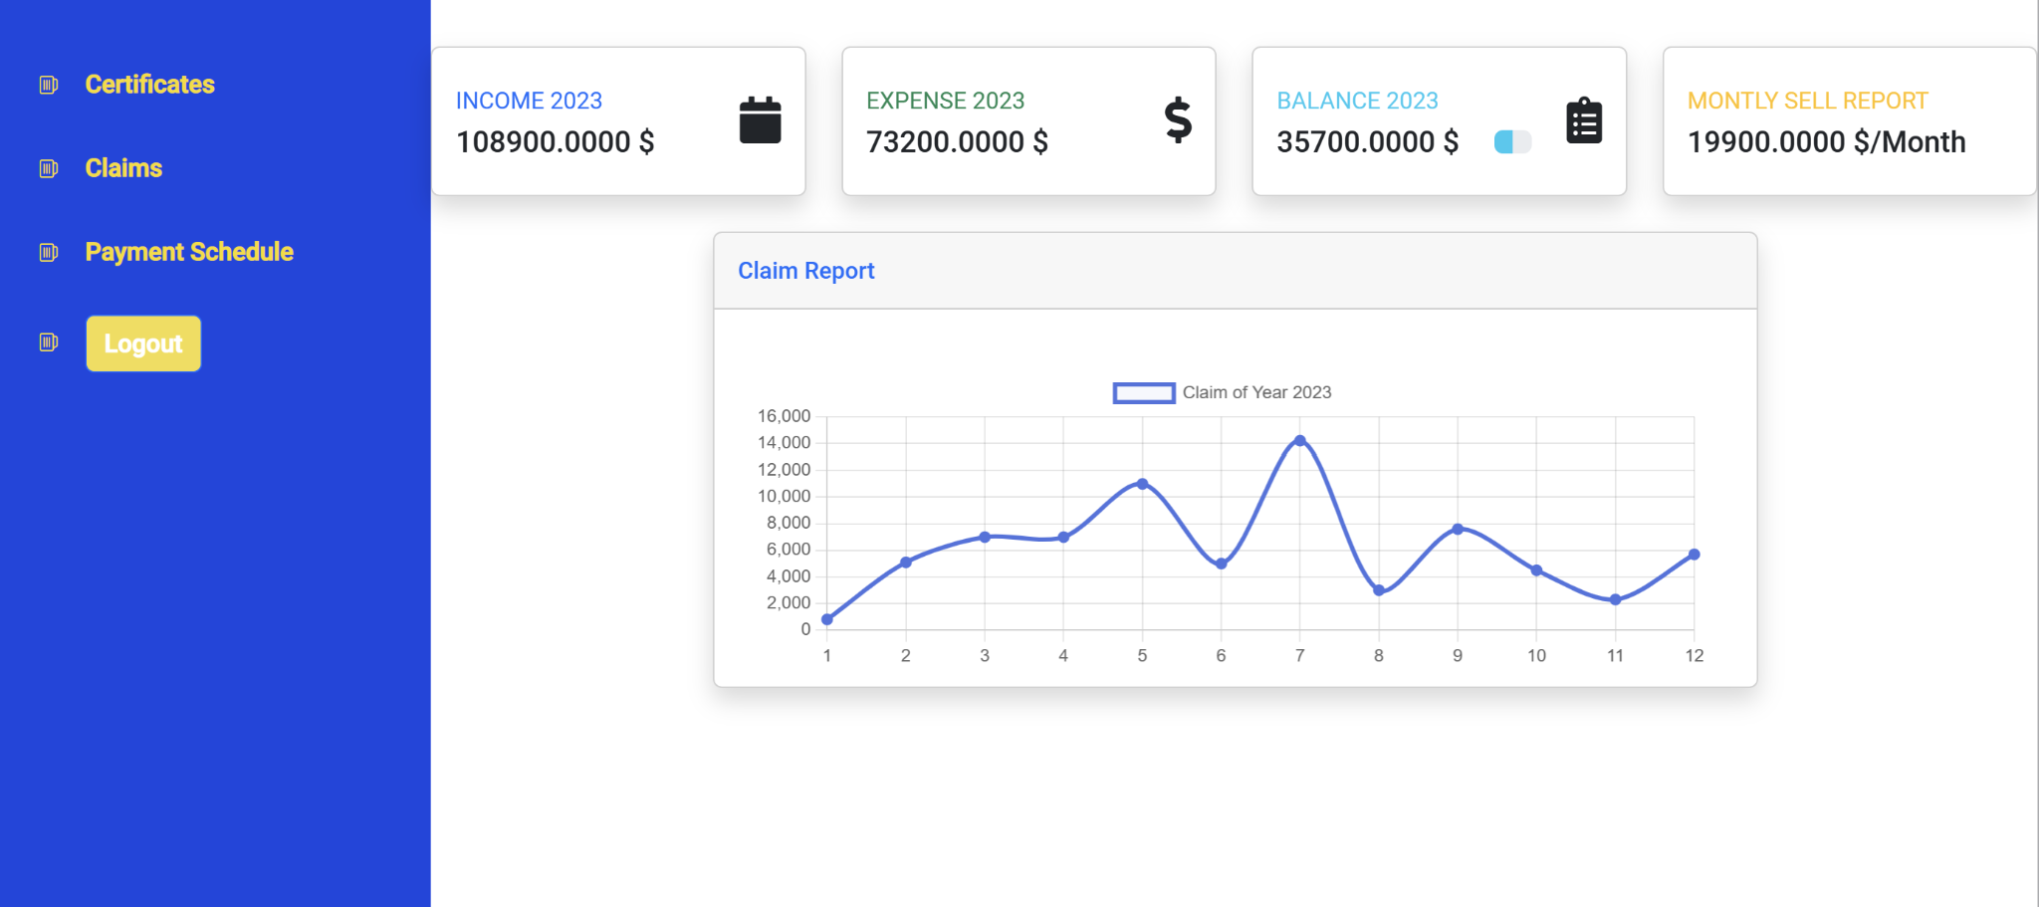

| **No.** | **Name** | **Type** | **Event** | **Description** |
| --- | --- | --- | --- | --- |
| 1 | Income 2023 | Chart | Not Event | Total customer bill in for year |
| 2 | Expense 2023 | Chart | Not Event | Total claim bill in for year |
| 3 | Balance 2023 | Chart | Not Event | Company profit in for year |
| 4 | Monthly Sell Report | Chart | Not Event | The company's revenue in the most recent month |
| 5 | Certificates | Button | Click | Go to Certificates page |
| 6 | Claims | Button | Click | Go to Claims page |
| 7 | Logout | Button | Click | Go to Login page |

#### Certificates page

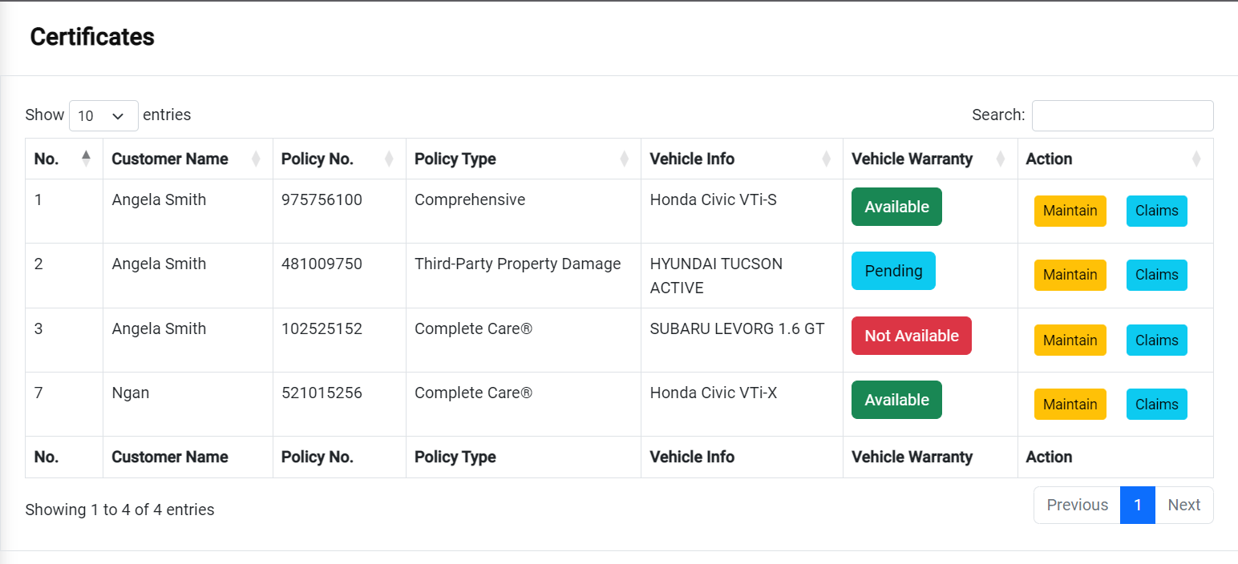

| **No.** | **Name** | **Type** | **Event** | **Description** |
| --- | --- | --- | --- | --- |
| 1 | Maintain | Button | Click | Click to go to maintain certificate page |
| 2 | Claims | Button | Click | Click to go to Claims by this certificate page |

#### Certificate Details - Maintain policy

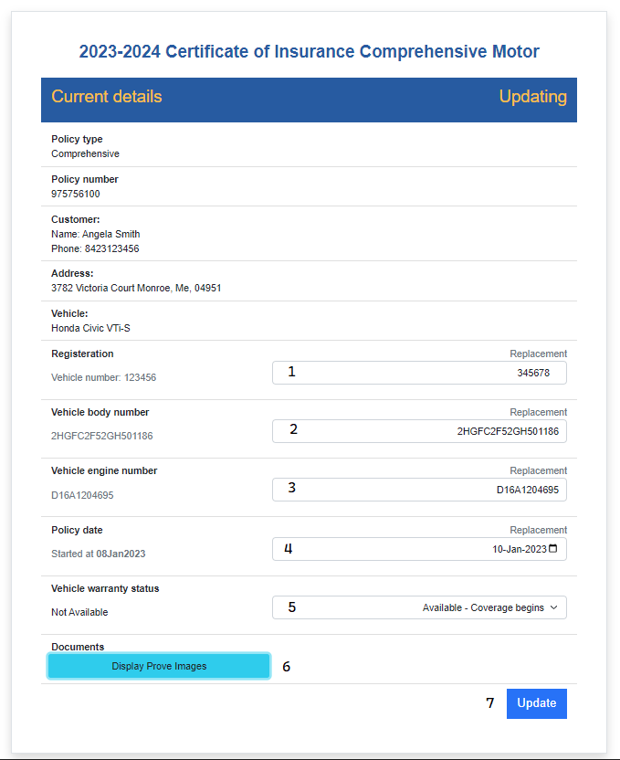

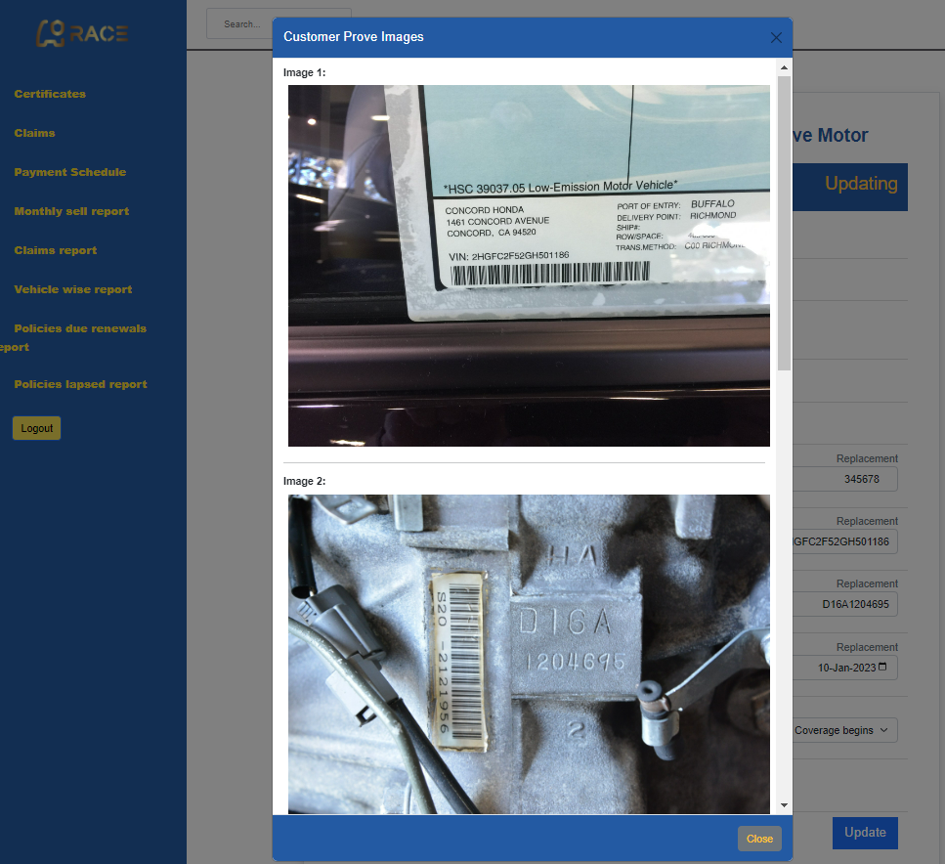

| **No.** | **Name** | **Validate** | **Type** | **Event** | **Description** |
| --- | --- | --- | --- | --- | --- |
| 1 | Vehicle number | 5-10 digits | Textbox | On Type | Input vehicle number |
| 2 | Vehicle body number | 6-20 characters not contain the specials | Textbox | On Type | Input Vehicle body number |
| 3 | Vehicle engine number | 6-15 characters not contain the specials | Textbox | On Type | Input Vehicle engine number |
| 4 | Policy Date | Required | Date picker | Choose | Choose policy new start date |
| 5 | Vehicle Warranty | Not validate | Select list | Select | Update status for vehicle warranty |
| 6 | Display Images | Not validate | Button | Click | Employee check prove images |
| 7 | Update | Confirm | Button | Click | Employee can update those fields above as duty |

#### Claims by this certificate

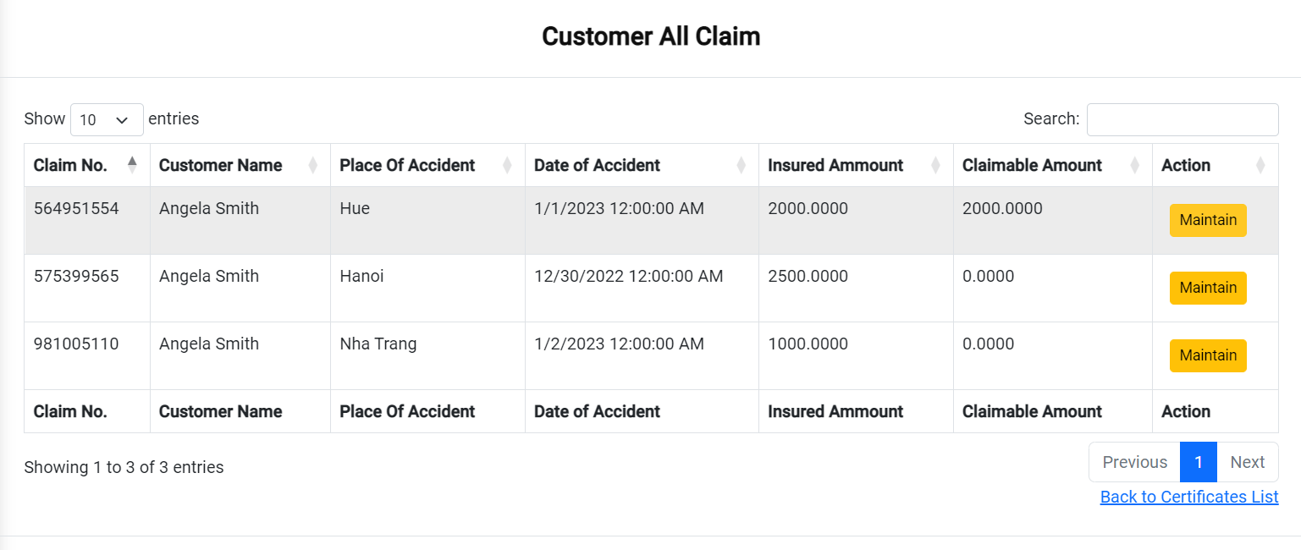

| **No.** | **Name** | **Type** | **Event** | **Description** |
| --- | --- | --- | --- | --- |
| 1 | Maintain | Button | Click | Click to go to maintain certificate page |
| 2 | Back to Certificates List | Button | Click | Click to go to Certificates page |

#### Claims

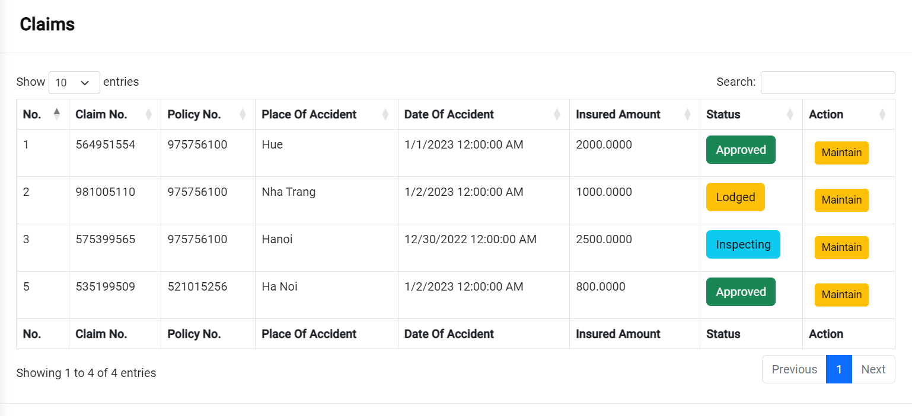

| **No.** | **Name** | **Type** | **Event** | **Description** |
| --- | --- | --- | --- | --- |
| 1 | Maintain | Button | Click | Click to go to maintain claim page |

#### Maintain claims

| **No.** | **Name** | **Type** | **Event** | **Description** |
| --- | --- | --- | --- | --- |
| 1 | Choose | Dropdown | Click | Click to choose status of Claim |
| 2 | Input | Number | Not Event | Insert Claimable amount |
| 3 | Confirm | Button | Click | Click to update status of claim |

#### Customer Bill

| **No.** | **Name** | **Type** | **Event** | **Description** |
| --- | --- | --- | --- | --- |
| 1 | Maintain | Button | Click | Click to go to maintain customer bill page |

#### Maintain customer bill

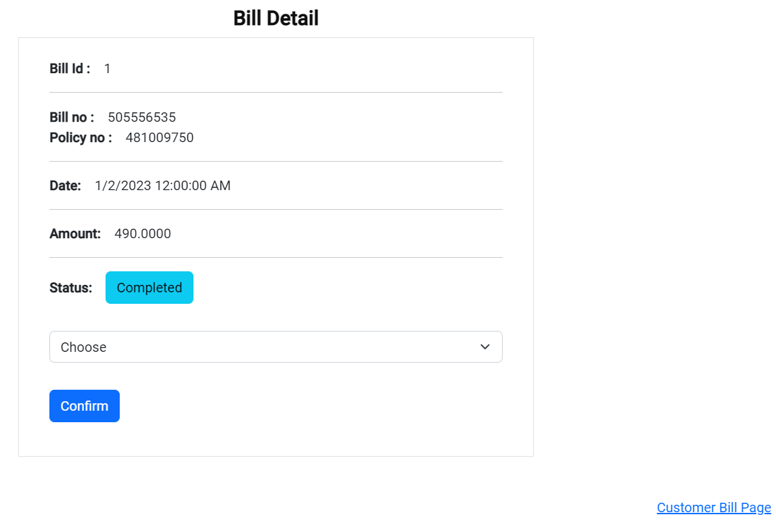

| **No.** | **Name** | **Type** | **Event** | **Description** |
| --- | --- | --- | --- | --- |
| 1 | Choose | Dropdown | Click | Click to choose status of Bill |
| 2 | Confirm | Button | Click | Click to update status of Bill |
| 3 | Customer Bill Page | Link | Click | Click to go to Customer Bill page |

#### Company Expense

| **No.** | **Name** | **Type** | **Event** | **Description** |
| --- | --- | --- | --- | --- |
| 1 | Detail | Button | Click | Click to go to details of a claim |

#### Company Expense Details

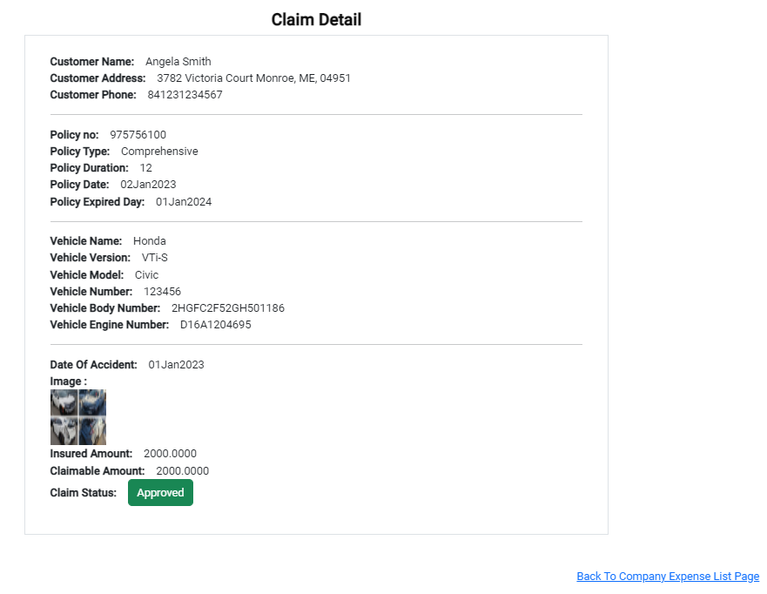

| **No.** | **Name** | **Type** | **Event** | **Description** |
| --- | --- | --- | --- | --- |
| 1 | Back to Company Expense List Page | Link | Click | Click to go to Company Expense Page |

#### Vehicle wise report page

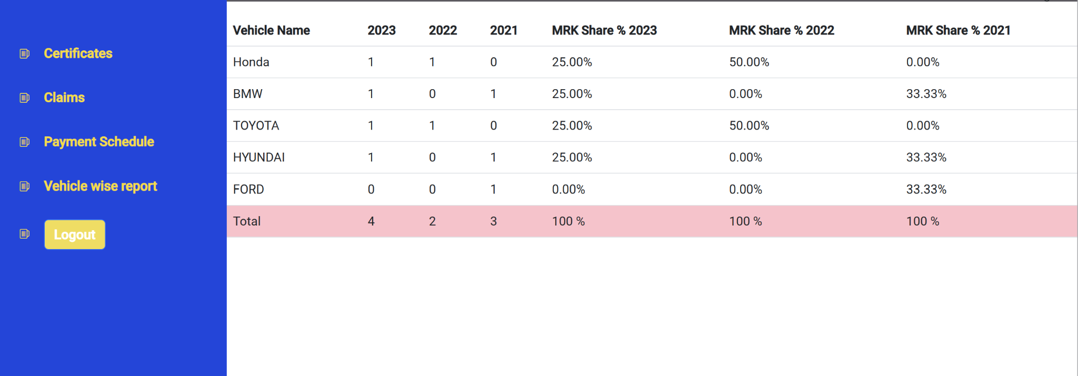

| **No.** | **Name** | **Event** | **Description** |
| --- | --- | --- | --- |
| 1 | Vehicle Name | Not Event | Vehicle Name |
| 2 | 2023 | Not Event | Total vehicle in 2023 |
| 3 | 2022 | Not Event | Total vehicle in 2022 |
| 4 | 2021 | Not Event | Total vehicle in 2021 |
| 5 | MRK Share % 2023 | Not Event | Total percent vehicle in 2023 |
| 6 | MRK Share % 2022 | Not Event | Total percent vehicle in 2022 |
| 7 | MRK Share % 2021 | Not Event | Total percent vehicle in 2021 |

#### Policies lapsed report

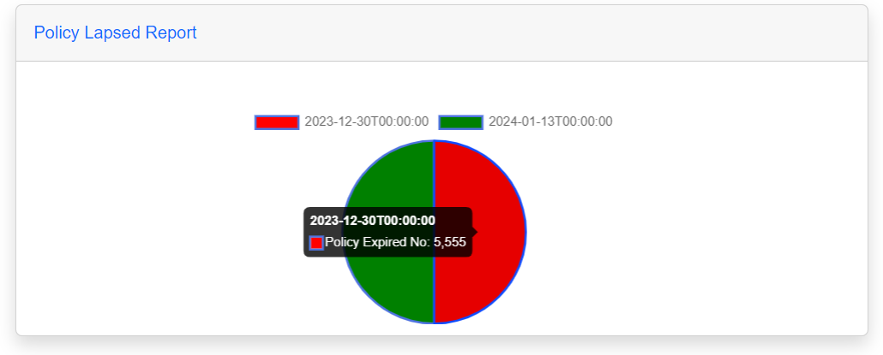

| **No.** | **Name** | **Type** | **Event** | **Description** |
| --- | --- | --- | --- | --- |
| 1 | Policy Lapsed Report | Button | Click | Click to go to Policy Lapsed Report Page |

### Customer

#### Header

| **No.** | **Name** | **Validate** | **Type** | **Event** | **Description** |
| --- | --- | --- | --- | --- | --- |
| 1 | My Certificate | Not Validate | Button | Click | Click to go to Certificates page |
| 2 | Logout | Not Validate | Button | Click | Logout |
| 3 | About Us | Not Validate | Link | Click | Click to go to About Us page |
| 4 | Sitemap | Not Validate | Link | Click | Click to go to Sitemap page |
| 5 | Contact | Not Validate | Link | Click | Click to go to Contact page |

#### Footer

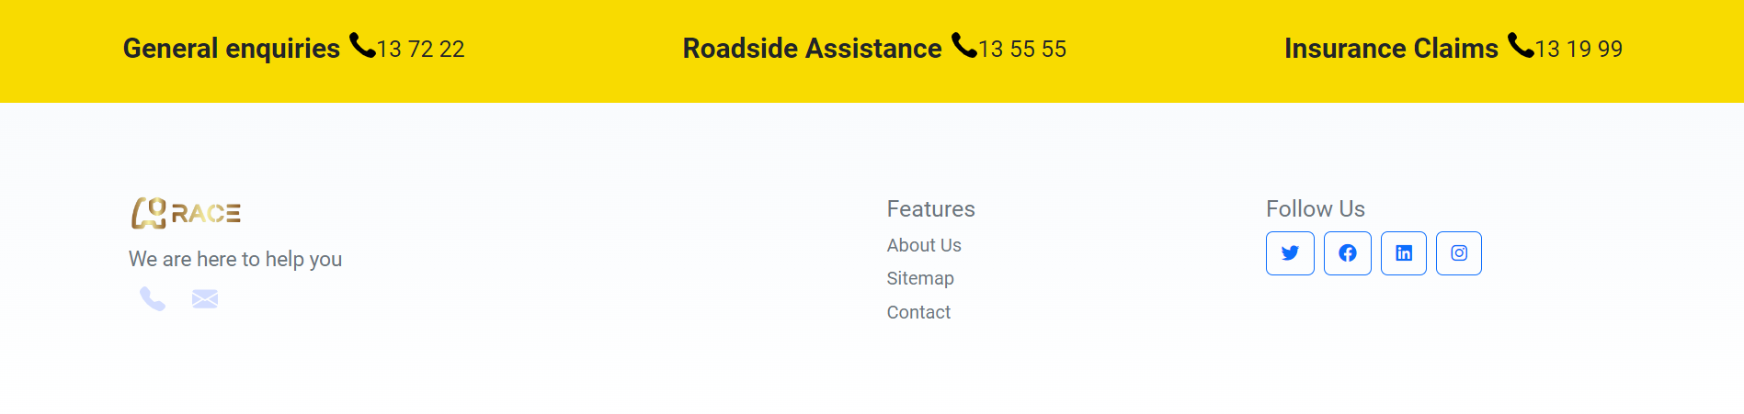

| **No.** | **Name** | **Validate** | **Type** | **Event** | **Description** |
| --- | --- | --- | --- | --- | --- |
| 1 | About Us | Not Validate | Link | Click | Click to go to About Us page |
| 2 | Sitemap | Not Validate | Link | Click | Click to go to Sitemap page |
| 3 | Contact | Not Validate | Link | Click | Click to go to Contact page |

#### Home

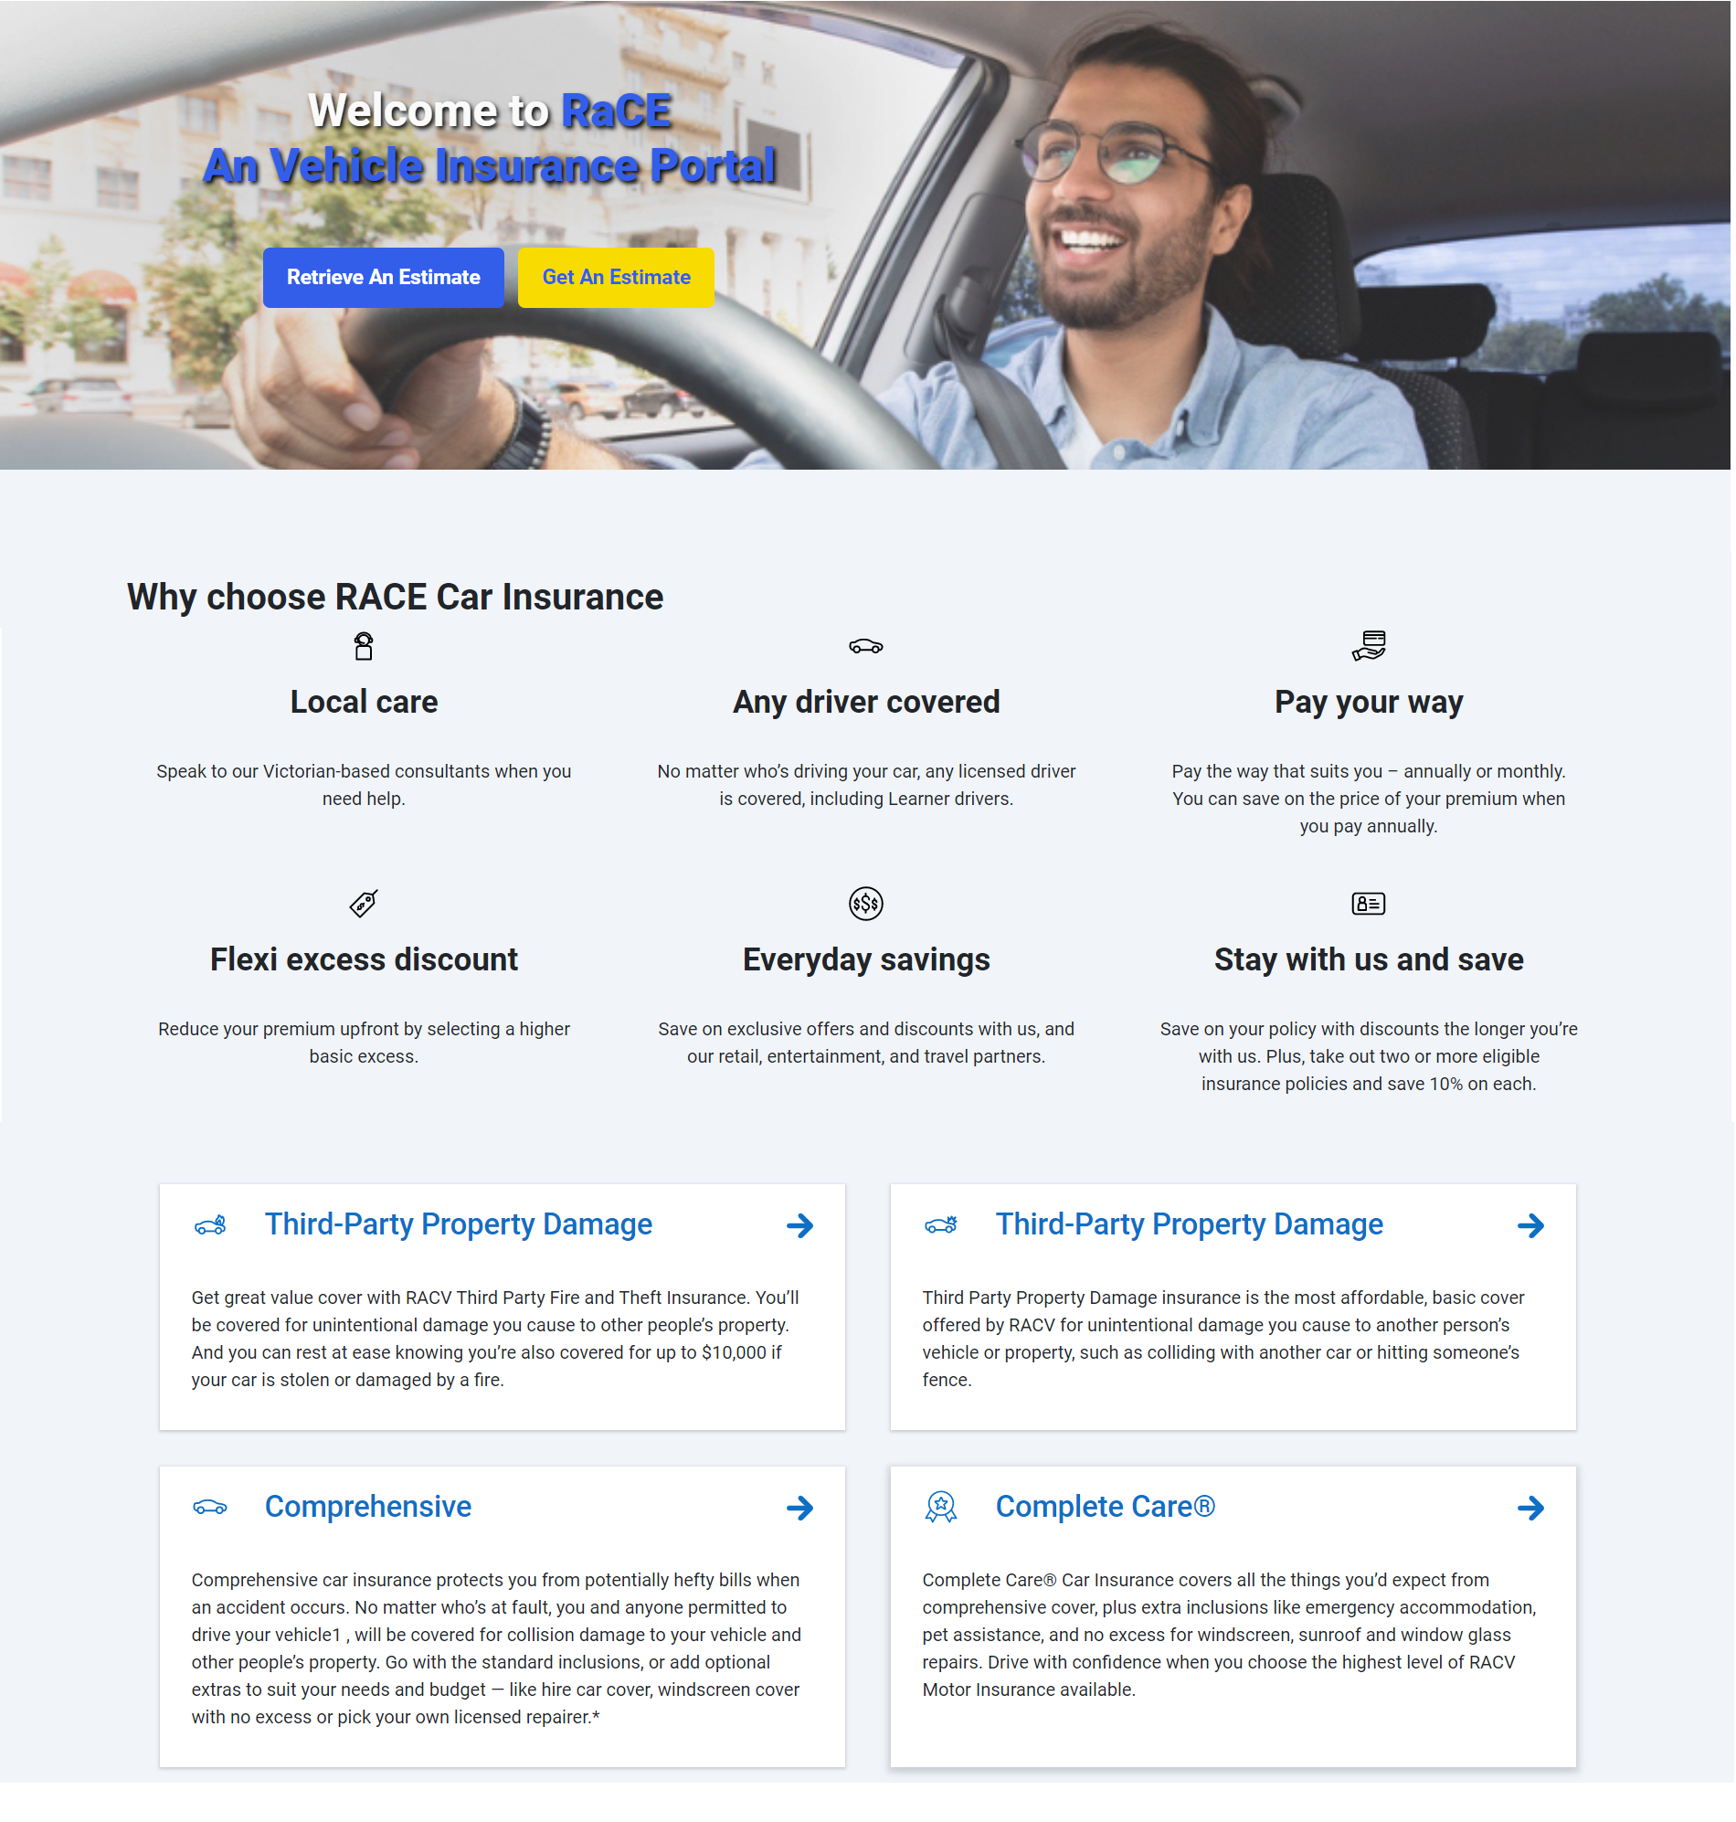

#### Personal Information

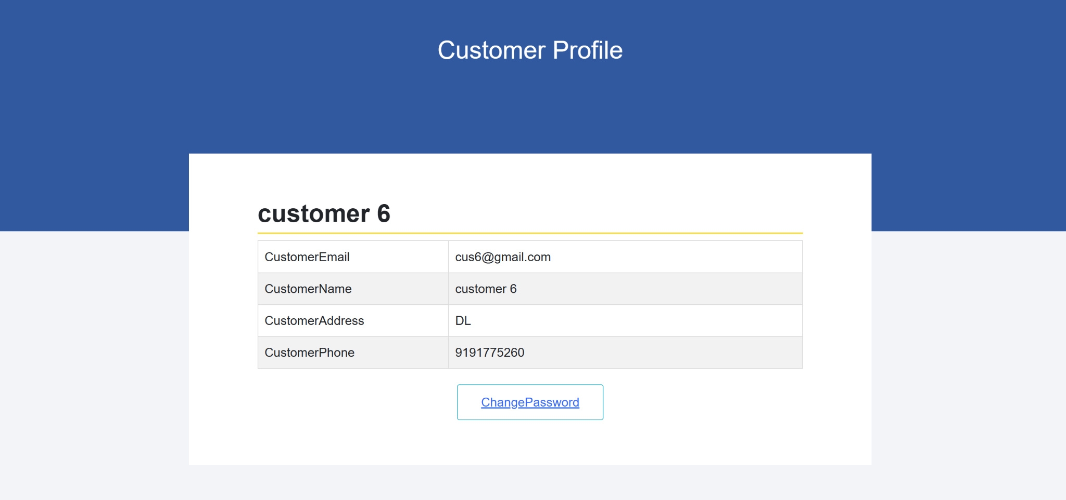

| **No.** | **Name** | **Type** | **Event** | **Description** |
| --- | --- | --- | --- | --- |
| 1 | Customer profile | Href | Click | Customer Profile Details after Customer login |
| 2 | Change Password | Href | Click | Go to Change Password Page |

#### Change Password

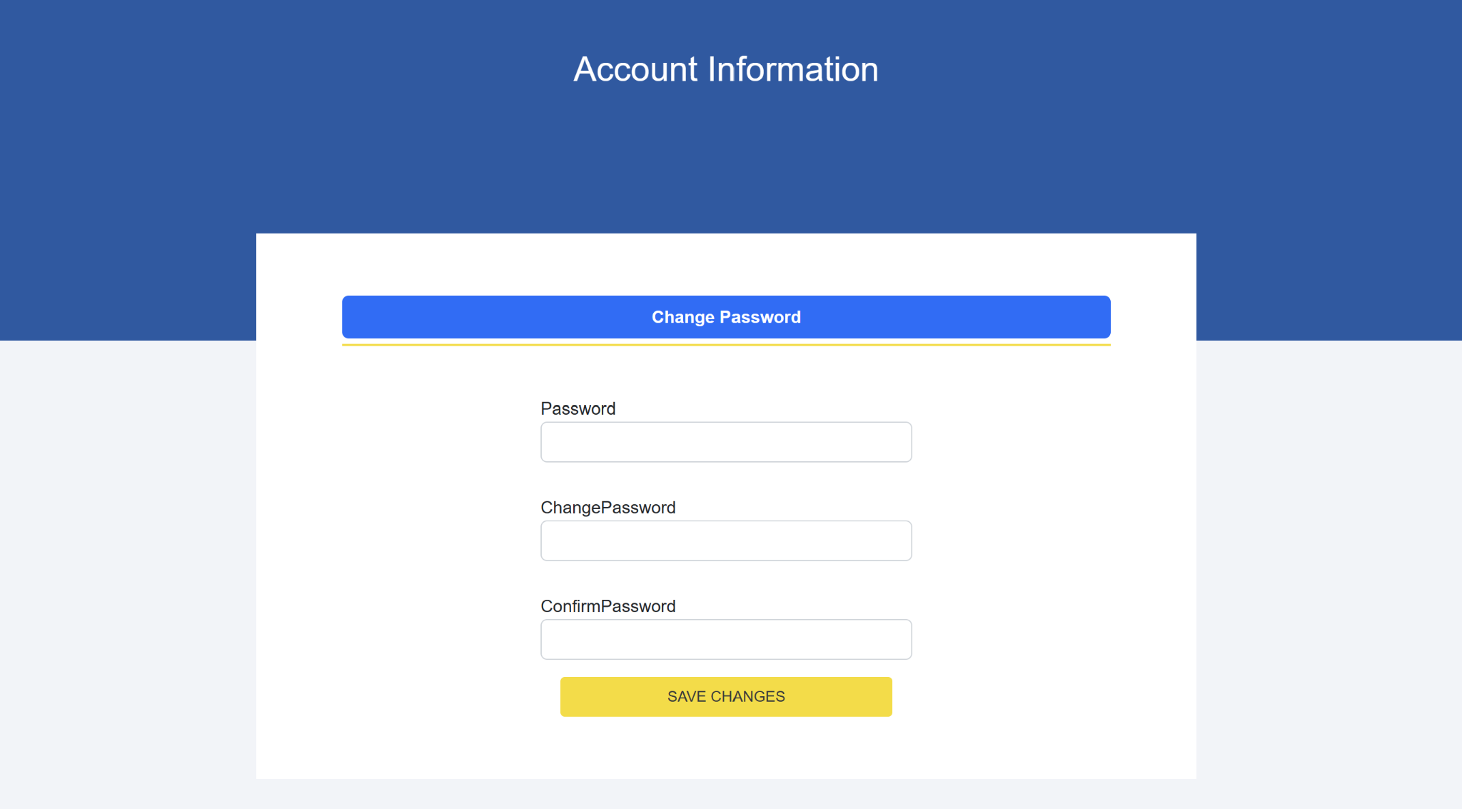

| **No.** | **Name** | **Validate** | **Type** | **Event** | **Description** |
| --- | --- | --- | --- | --- | --- |
| 1 | Password | Required | Textbox | On Type | Current password |
| 2 | Change password | Must be 8 characters including one uppercase letter, one lowercase letter, and one number or special character | Textbox | On Type | New password |
| 3 | Confirm password | Must be 8 characters including one uppercase letter, one lowercase letter, and one number or special character | Textbox | On Type | Confirm new password |

#### Login

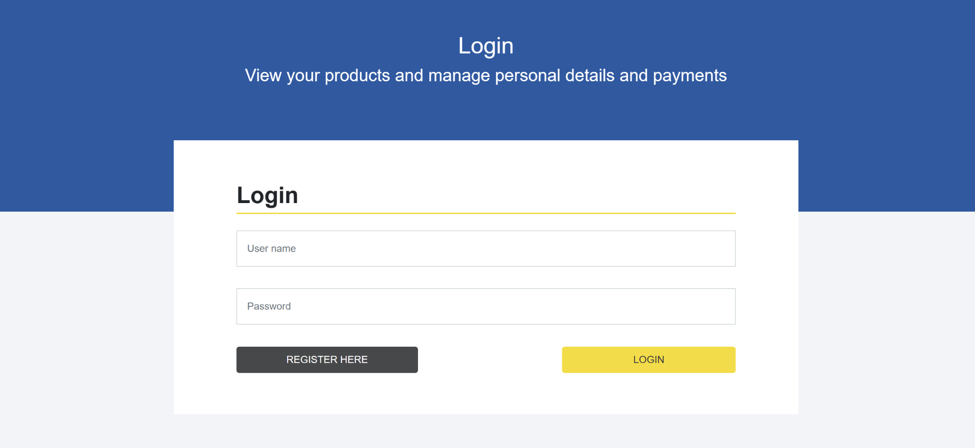

| **No.** | **Name** | **Validate** | **Type** | **Event** | **Description** |
| --- | --- | --- | --- | --- | --- |
| 1 | User name | Required | Textbox | On Type | Customer User |
| 2 | Password | Required | Textbox | On Type | Customer password |
| 3 | Register Here | Not Validate | Button | Click | Go to Register page |

#### Register

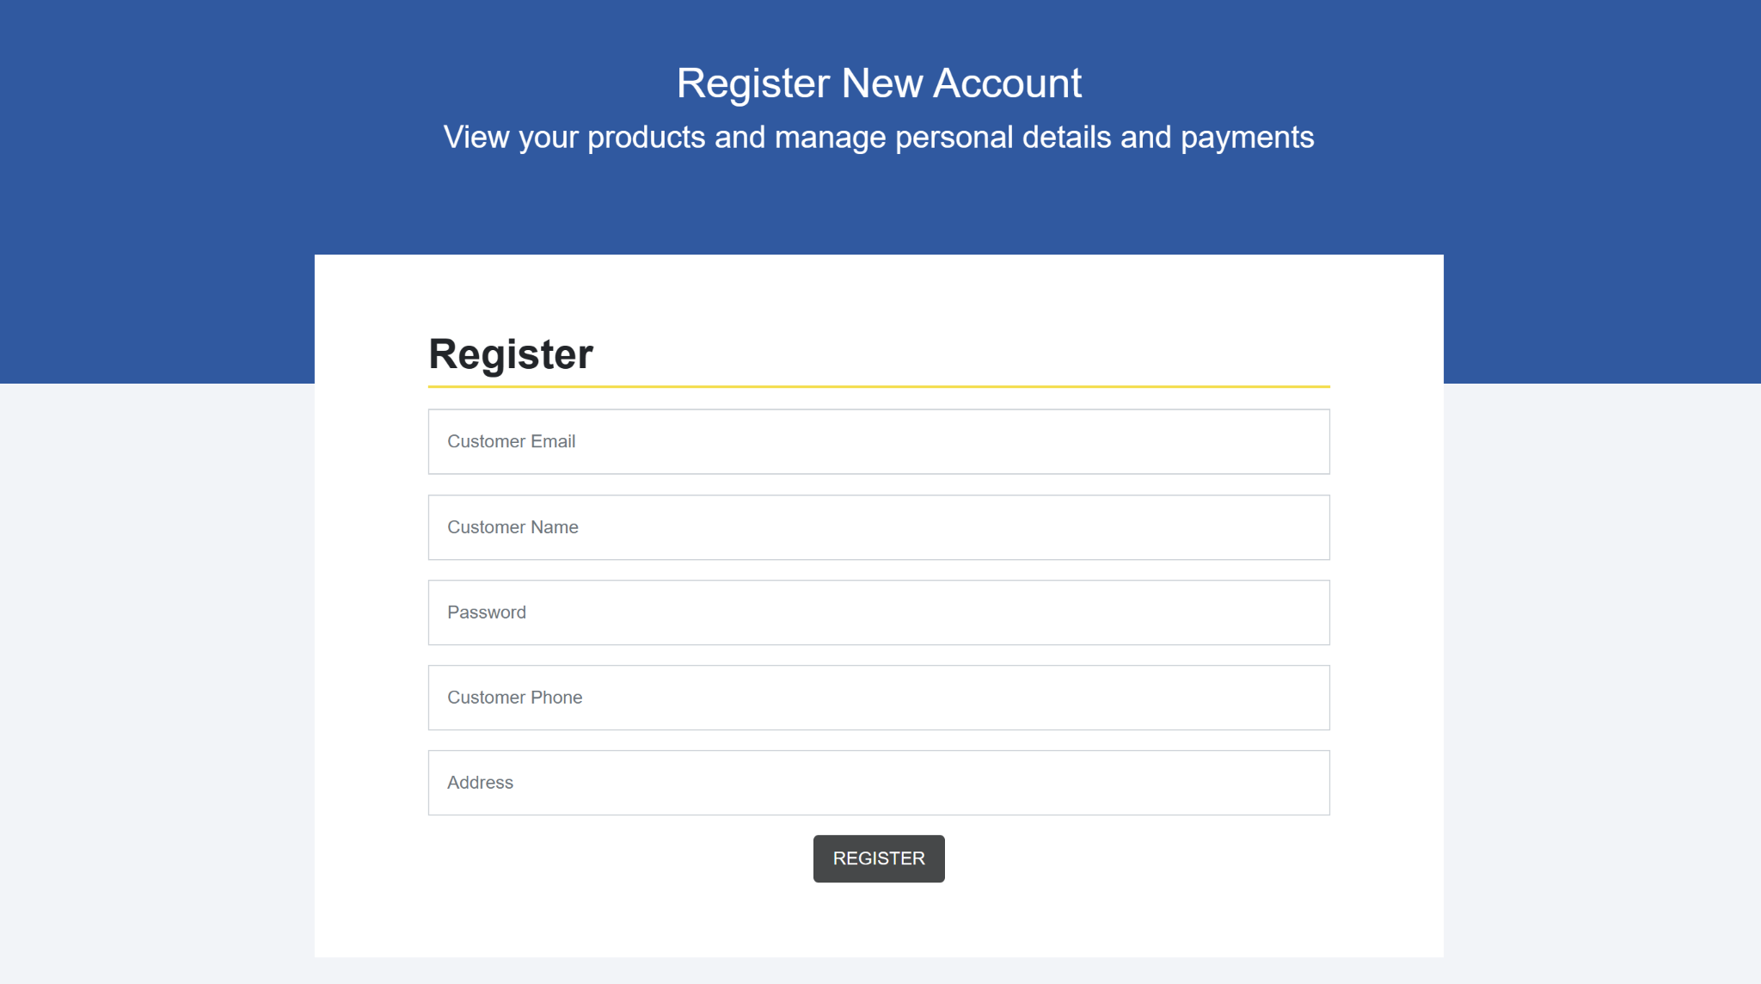

| **No** | **Name** | **Validate** | **Type** | **Event** | **Description** |
| --- | --- | --- | --- | --- | --- |
| 1 | Register | Not Validate | Button | Click | Click to go to Login page |
| 2 | Customer Email | Must be email | Textbox | On Type | Customer Email |
| 3 | Customer Name | Must be between 2 to 30 character | Textbox | On Type | Customer Name |
| 4 | Password | Must be 8 characters including one uppercase letter, one lowercase letter, and one number or special character | Textbox | On Type | Customer Password |
| 5 | Phone | Required | Textbox | On Type | Phone |
| 6 | Address | Not Validate | Textbox | On Type | Customer Address |

#### About Us

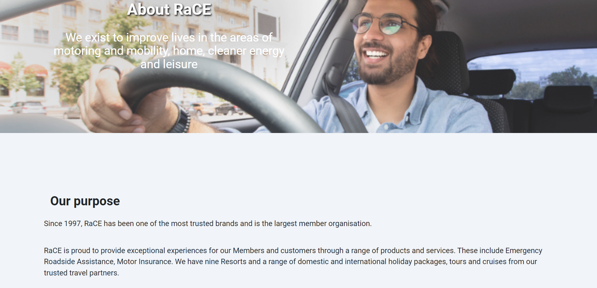

#### Sitemap

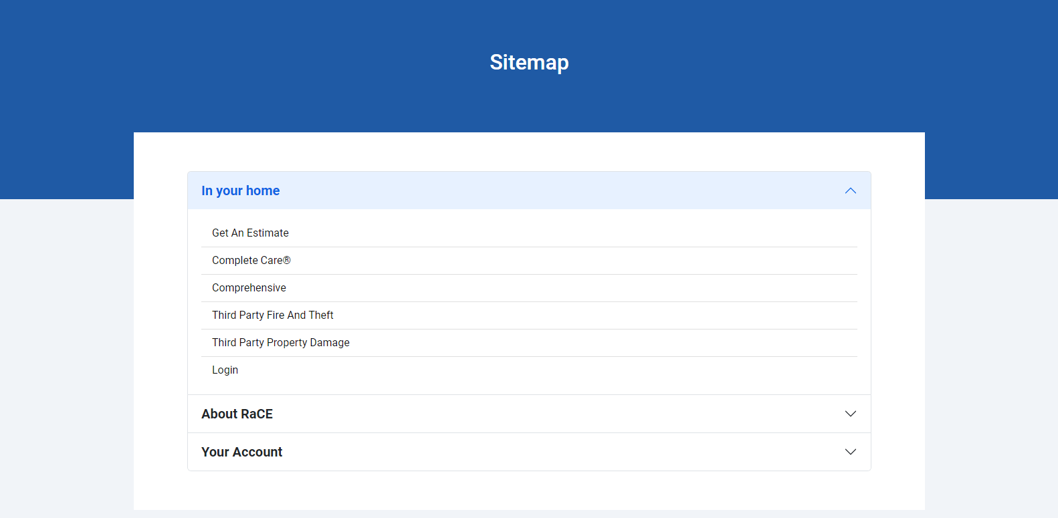

| **No.** | **Name** | **Validate** | **Type** | **Event** | **Description** |
| --- | --- | --- | --- | --- | --- |
| 1 | In Your Home | Not Validate | Dropdown | Click | Click to display list of pages available in Index page |
| 2 | About RaCE | Not Validate | Dropdown | Click | Click to display list of pages about RaCE |
| 3 | Your Account | Not Validate | Dropdown | Click | Click to display list of pages about account |

#### Testimonials

#### Contact Us

#### List of Insurance Policies

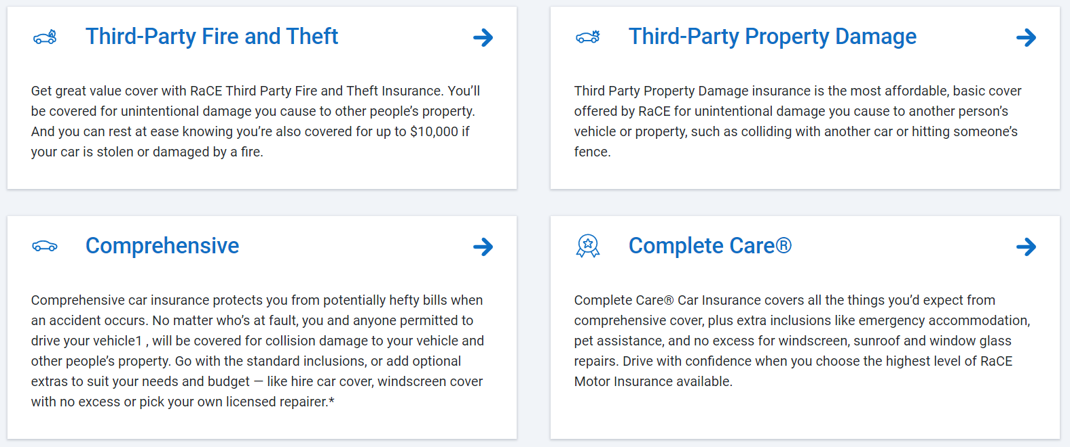

| **No.** | **Name** | **Type** | **Event** | **Description** |
| --- | --- | --- | --- | --- |
| 1 | Third-Party Property Damage | Button | Not Event | Click to go to Third-Party Property Damage policy page |
| 2 | Third-Party Property Fire and Theft | Button | Not Event | Click to go to Third-Party Property Fire and Theft policy page |
| 3 | Comprehensive | Button | Not Event | Click to go to Comprehensive policy page |
| 4 | Complete Care | Button | Not Event | Click to go to Complete Care policy page |

#### My Claims

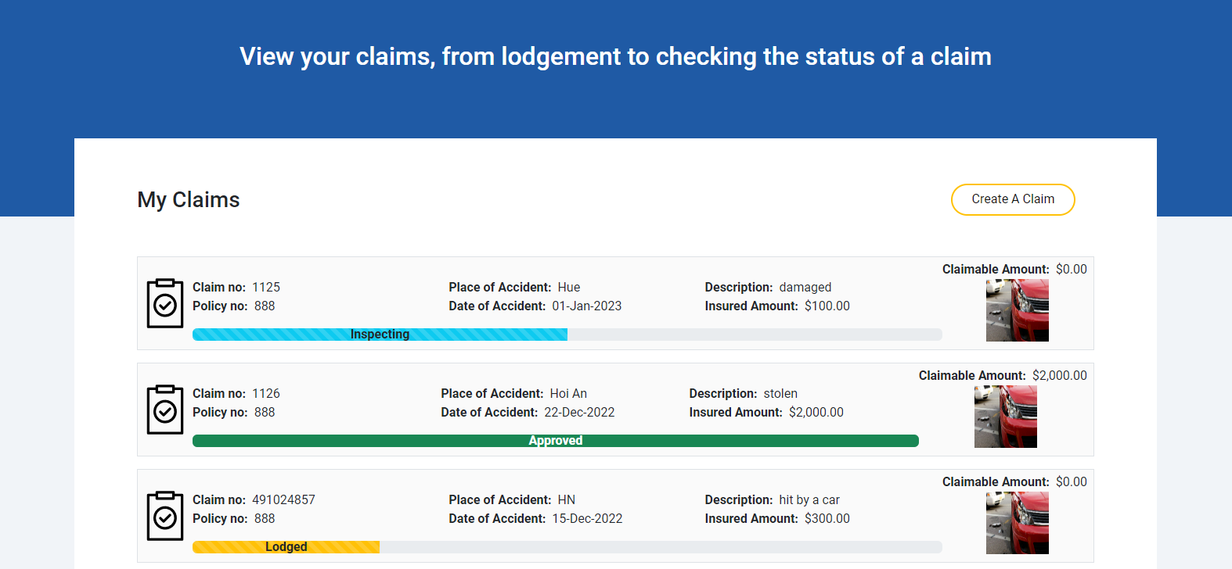

| **No.** | **Name** | **Validate** | **Type** | **Event** | **Description** |
| --- | --- | --- | --- | --- | --- |
| 1 | Create A Claim | Not Validate | Button | Click | Click to go to Create Claim page |

#### Form Claim

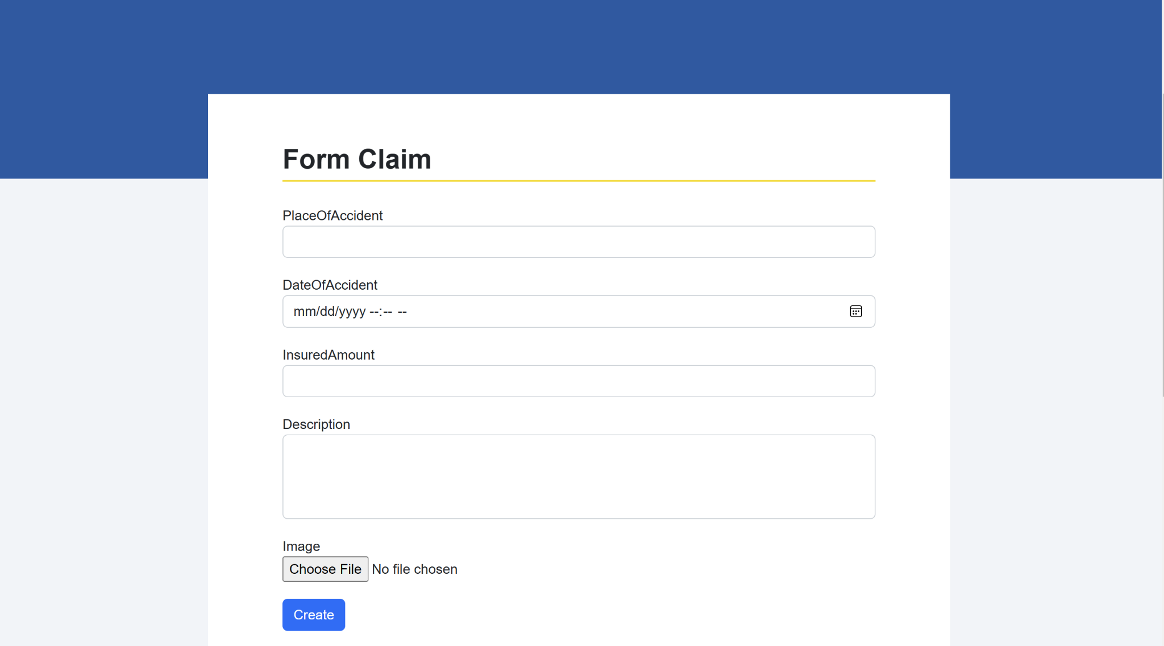

| **No.** | **Name** | **Validate** | **Type** | **Event** | **Description** |
| --- | --- | --- | --- | --- | --- |
| 1 | Create | Not Validate | Button | Click | Click to go to Certificate Page |
| 2 | Place of Accident | Required | Textbox | On Type | Place of Accident |
| 3 | Date of Accident | Required | Textbox | On Type | Date of Accident |
| 4 | Insured Amount | Required | Textbox | On Type | Insured Amount |
| 5 | Description | Required | Textbox | On Type | Description |
| 6 | Image | Must be png,jpg, required | File | Choose | Choose Image |

#### Estimate

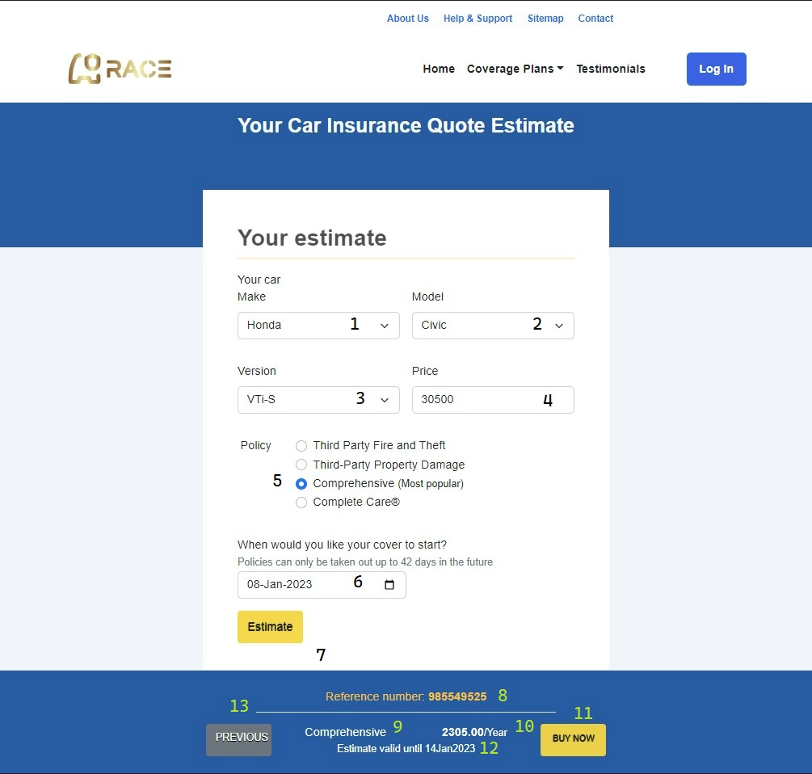

| **No.** | **Name** | **Validate** | **Type** | **Event** | **Description** |
| --- | --- | --- | --- | --- | --- |
| 1 | Vehicle Name | Required | Dropdown List | Select | Select Vehicle Name |
| 2 | Vehicle Model | Required | Dropdown List | Select | Select Vehicle Model |
| 3 | Vehicle Version | Required | Dropdown List | Select | Select Vehicle Version |
| 4 | Vehicle Rate | Required | Textbox | On Type | Input Vehicle Rate |
| 5, 9 | Policy Type | Required | Radio Button | Select | Select Policy Type |
| 6 | Policy Date | Required, up to 42 days in the future | Date picker | Choose | Choose policy start date |
| 7 | Estimate | Not validate | Button | Click | Click to get an estimate premium |
| 8 | Estimate No | Readonly | Display | Display | Serial number identifier for an estimate |
| 10 | Premium | Readonly | Display | Display | Premium customer pay annually if buy this policy |
| 11 | BUY NOW | Not validate | Button | Click | Click to Contract form page |
| 12 | Estimate expiration time | Readonly | Cookie | Display | Describe expiration time of this estimate (14 days) |
| 13 | Previous | Not validate | Button | Click | Back to homepage |

#### Contract

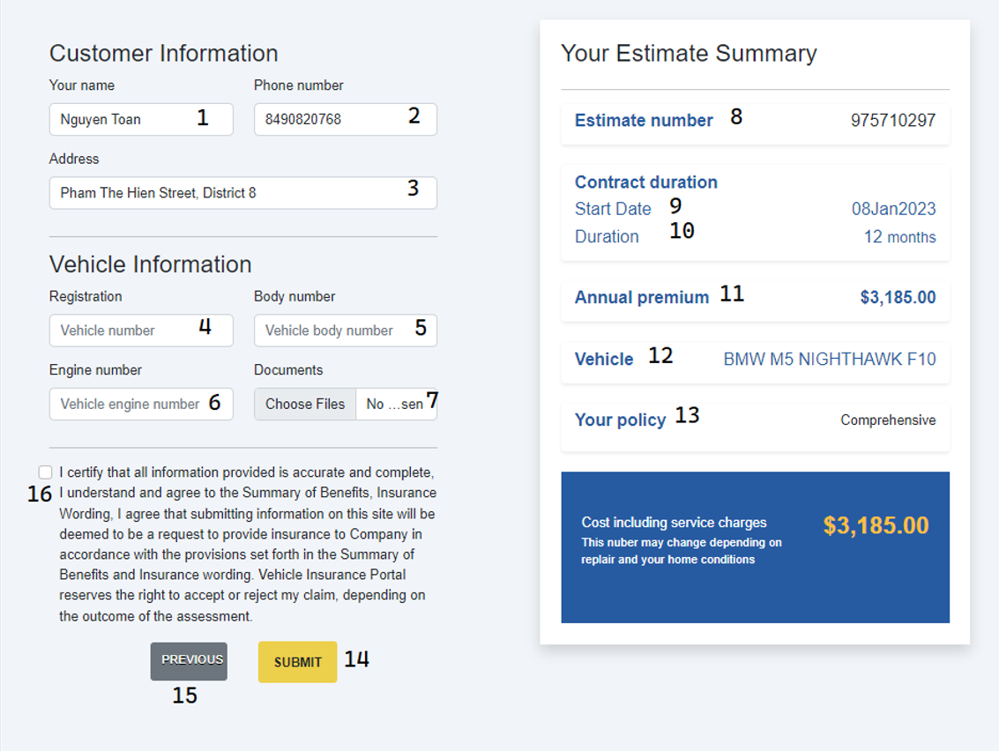

| **No.** | **Name** | **Validate** | **Type** | **Event** | **Description** |
| --- | --- | --- | --- | --- | --- |
| 1 | Customer Name | Readonly | Display | Display | Get customer information from account login |
| 2 | Customer phone | Readonly | Display | Display | Get customer information from account login |
| 3 | Customer address | Readonly | Display | Display | Get customer information from account login |
| 4 | Vehicle number | Required,  5-10 digits | Textbox | On Type | Input registration number of the vehicle |
| 5 | Vehicle body number | Required,  6-20 characters not contain the specials | Textbox | On Type | Input body number of the vehicle |
| 6 | Vehicle engine number | Required,  6-15 characters not contain the specials | Textbox | On Type | Input engine number of the vehicle |
| 7 | Documents | Required, Must be png,jpg or jpeg | Files | Choose | Choose prove image files |
| 8 | Estimate No | Not validate | Display | Display | Serial number identifier for an estimate |
| 9 | Policy Date | Readonly | Display | Display | Display from Estimate information |
| 10 | Policy Duration | Readonly | Display | Display | Display from Estimate information |
| 11 | Premium | Readonly | Display | Display | Display from Estimate information |
| 12 | Vehicle Name/ Model/ Version | Readonly | Display | Display | Display from Estimate information |
| 13 | Policy Type | Readonly | Display | Display | Display from Estimate information |
| 14 | SUBMIT | Not validate | Button | Click | Click to create Certificate and link to Certificate page of a customer |
| 15 | Previous | Not validate | Button | Click | Back to estimate page |
| 16 | Agreement | Must check | Checkbox | On check | Terms & Conditions agreement |

#### Certificates

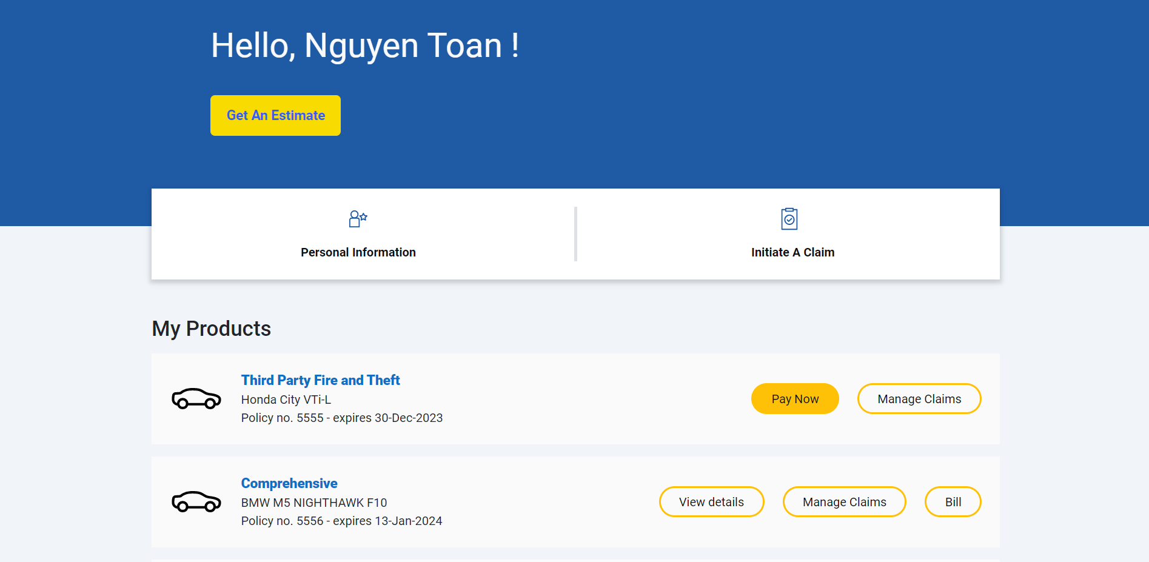

| **No.** | **Name** | **Validate** | **Type** | **Event** | **Description** |
| --- | --- | --- | --- | --- | --- |
| 1 | Personal Information | Not Validate | Button | Click | Click to go to Personal Information page |
| 2 | Initiate A Claim | Not Validate | Button | Click | Click to go to Initiate A Claim page |
| 3 | Pay Now | Not Validate | Button | Click | Details of Certificate to pay |
| 4 | Manage Claims | Not Validate | Button | Click | Details of Certificate belongs to this certificate |
| 5 | Bill | Not Validate | Button | Click | Details of Bill of this certificate |

#### Certificate Details

| **No.** | **Name** | **Validate** | **Type** | **Event** | **Description** |
| --- | --- | --- | --- | --- | --- |
| 1 | Print your certificate | Not Validate | Button | Click | Click to go to display print window |

#### Bill

#### Payment

* + 1. Pay Later method

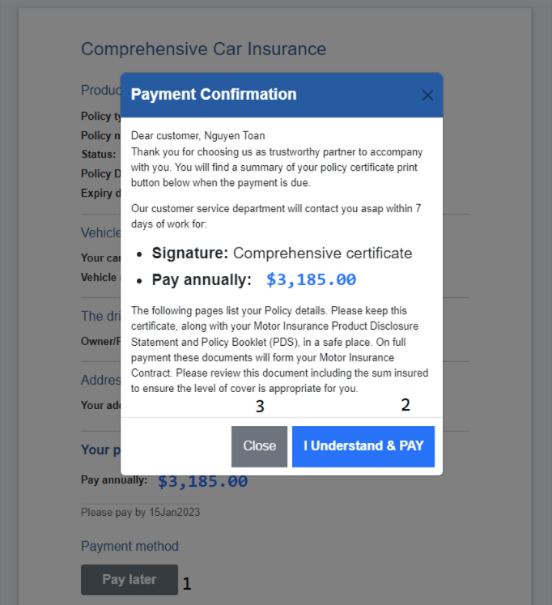

| **No.** | **Name** | **Type** | **Event** | **Description** |
| --- | --- | --- | --- | --- |
| 1 | Pay later | Button | Click | Choose pay later method |
| 2 | I Understand & PAY | Button | Click | Payment Confirmation to Create Bill with Status “Pending” |
| 3 | Close | Button | Click | Close modal |

# Task Sheet Review 3

| **Project Ref. No.:**  **eP/Vehicle-Insurance- Management/04** | | **Project Title:** | **Activity Plan**  **Prepared**  **By:** | **Date of Preparation of Activity Plan:** | | | |
| --- | --- | --- | --- | --- | --- | --- | --- |
| **Sr. No.** | **Task** | **Actual Start**  **Date** | **Actual**  **Days** | **Team**  **Mate**  **Names** | **Status** |
| 1 | Site Map | Vehicle Insurance Portal | Nguyen Ngoc Kim Ngan | 10Dec 2022 | 22 | Truong Duong Truc Duy, Nguyen Phuc Duy | Completed |
| 2 | Database Design | 10Dec 2022 | 22 | Nguyen Toan | Completed |
| 3 | GUI Design | 10Dec 2022 | 22 | All members | Completed |
| 4 | Entity- Relationship Diagram | 10Dec 2022 | 22 | Nguyen Toan | Completed |
| 5 | Task sheet review | 10Dec 2022 | 22 | Nguyen Ngoc Kim Ngan | Completed |
| 6 | * Customer   1. Layout  2. Home: App + Api  3. Testimonials 4. Sitemap 5. My Certificates: App + Api -6. Details My Certificates: App + Api 7. Bill 8. My Claims: App + Api   * Employee   1. Layout  2. Claims: App + Api 3. Maintain claim: App + Api |  |  |  |  | Nguyen Ngoc Kim Ngan | Completed |
| 7 | - Sql script   * Customer   1. Get An Estimate: App + Api 2. Retrieve An Estimate: App + Api 3. Contract: App + Api 4. Pay later: App + Api   * Employee   1. Maintain Certificate: App + Api |  |  |  |  | Nguyen Toan | Completed |
| 8 | * Customer   1. Login: App + Api 2. Logout: App + Api 3. Change Password: App + Api 4. Register: App + Api 5. Detail customer: App + Api 6. Check login: App + Api 7. Claim form: App + Api   * Employee   1. Login: App + Api 2. Logout: App + Api 3. Dashboard (Claims report): App + Api - Dashboard (Monthly sell of policies): App + Api - Vehicle wise analysis: App + Api |  |  |  |  | Truong Duong Truc Duy | Completed |
| 9 | * Customer   1. Type of Insurance Policies: App + Api  2. Contact 3. About Us   * Employee   1. List of Certificates: App + Api 2. Details of Certificate: Api 3. List of Claims by this certificate: App + Api 4. List of Company Expense: App + Api 5. Company Expense Detail: App + Api 6. Customer Bill: App + Api 7. Policy Lapsed Report: App + Api |  |  |  |  | Nguyen Phuc Duy | Completed |
| **Date: 10/12/2022** | | | | | | | |
| **Signature of Instructor**    **Mr. Nguyen Kim Thuan** | | | | **Signature of Team Leader**    **Nguyen Ngoc Kim Ngan** | | | |